**1.Modelo RF5_Indeg Apoio Spe Diq Cint X All var**.

***Instrucciones modelo***: **test size = 0.17 ; rd_state = 30**

***Variables indep select to fit***:

variables = [ 'id', 'Indeg_IntimAmigos_',  'Indeg_RedeRisk_Cen', 'PC1_Distance_Pro', 'Degree_RedeTotFamil', '1_VarExp_Moranca', '2_VarExp_Atri_Tabanca']

***Model performance (scores):***

Mean Squared Error: 1.1818

R^2 Score: 0.5601 (In Excel: R2 = 0.5601 ; y = 0.4274 X + 1.0539)

**Model tot:**

Mean Squared Error (MSE): 0.5194

Root Mean Squared Error (RMSE): 0.7207

Mean Absolute Error (MAE): 0.4419

R^2 Score: 0.772

Pearson Correlation: 0.8992

***Interactions***:

| **Interacción** | **Importancia** | **Dirección** |
| --- | --- | --- |
| 0 | (1_VarExp_Moranca, 2_VarExp_Atri_Tabanca) | 0.535744 | 0.015768 |
| 1 | (Indeg_IntimAmigos_, 2_VarExp_Atri_Tabanca) | 0.530883 | -0.010837 |
| 2 | (Degree_RedeTotFamil, 2_VarExp_Atri_Tabanca) | 0.495715 | 0.006976 |
| 3 | (PC1_Distance_Pro, 2_VarExp_Atri_Tabanca) | 0.452591 | -0.005249 |
| 4 | (Indeg_RedeRisk_Cen, 2_VarExp_Atri_Tabanca) | 0.408551 | 0.047054 |
| 5 | (Indeg_RedeRisk_Cen, 1_VarExp_Moranca) | 0.280659 | 0.048542 |
| 6 | (PC1_Distance_Pro, 1_VarExp_Moranca) | 0.280614 | -0.004812 |
| 7 | (Degree_RedeTotFamil, 1_VarExp_Moranca) | 0.260620 | 0.010572 |
| 8 | (PC1_Distance_Pro, Degree_RedeTotFamil) | 0.257576 | -0.005734 |
| 9 | (Indeg_IntimAmigos_, 1_VarExp_Moranca) | 0.216361 | -0.003766 |

***Key results****:*

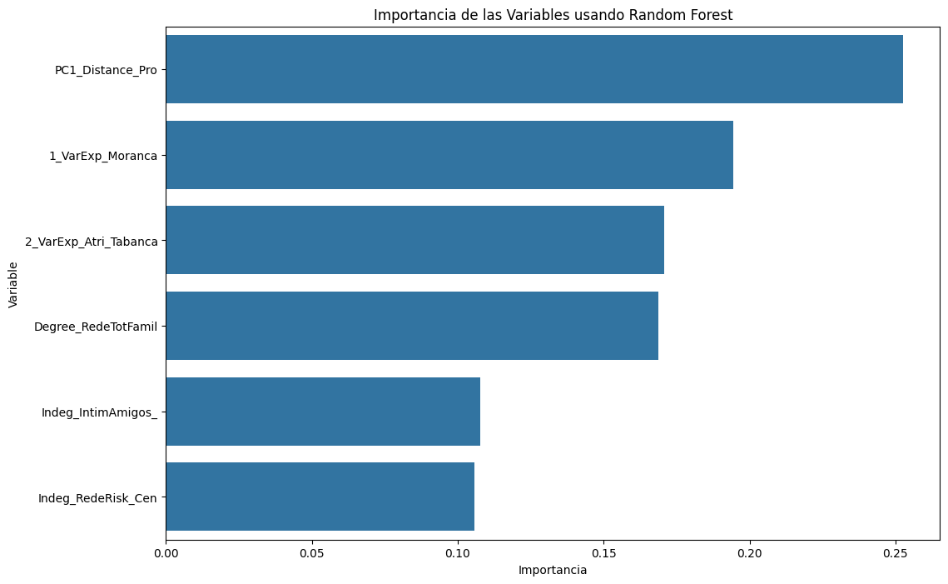

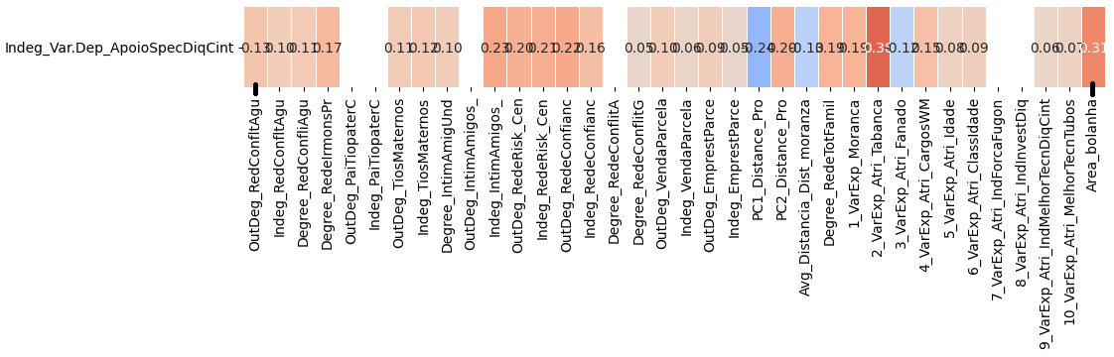

**2.Modelo RF5_Outdeg Apoio Spe Diq Cint X All var**.

***Instrucciones modelo***: **test size = 0.25, Rd_state = 15**.

***Variables indep select to fit***:

variables = ['id','Indeg_IntimAmigos_','Indeg_RedeRisk_Cen',

'Degree_RedeTotFamil', '1_VarExp_Moranca', '7_VarExp_Atri_IndForcaFugon',

  '8_VarExp_Atri_IndInvestDiq','9_VarExp_Atri_IndMelhorTecnDiqCint', '10_VarExp_Atri_MelhorTecnTubos', 'Area_bolanha', 'OutDeg_RedeRisk_Cen']

***Model performance (scores):***

Mean Squared Error: 1.0909

R^2 Score: 0.8427 (on excel: **R2= 0.8507 ; Y = 0.7986 X + 0.4198**)

**Model tot:**

Mean Squared Error (MSE): 0.8527

Root Mean Squared Error (RMSE): 0.9234

Mean Absolute Error (MAE): 0.4496

R^2 Score: 0.9323

Pearson Correlation: 0.9713

***Interactions***:

| **Interacción** | **Importancia** | **Dirección** |
| --- | --- | --- |
| 0 | (9_VarExp_Atri_IndMelhorTecnDiqCint, 10_VarExp... | 3.502650 | 0.468727 |
| 1 | (PC1_Distance_Pro, 10_VarExp_Atri_MelhorTecnTu... | 2.908421 | 0.004340 |
| 2 | (1_VarExp_Moranca, 10_VarExp_Atri_MelhorTecnTu... | 2.873877 | -0.005294 |
| 3 | (Indeg_IntimAmigos_, 10_VarExp_Atri_MelhorTecn... | 2.872133 | 0.169553 |
| 4 | (8_VarExp_Atri_IndInvestDiq, 10_VarExp_Atri_Me... | 2.869310 | 0.091475 |
| 5 | (10_VarExp_Atri_MelhorTecnTubos, Area_bolanha) | 2.866670 | 0.857471 |
| 6 | (10_VarExp_Atri_MelhorTecnTubos, OutDeg_RedeRi... | 2.864149 | 0.857264 |
| 7 | (Indeg_RedeRisk_Cen, 10_VarExp_Atri_MelhorTecn... | 2.860961 | 0.011005 |
| 8 | (7_VarExp_Atri_IndForcaFugon, 10_VarExp_Atri_M... | 2.860666 | 0.118550 |
| 9 | (Degree_RedeTotFamil, 10_VarExp_Atri_MelhorTec... | 2.853812 | 0.050528 |

***Key results****:*

